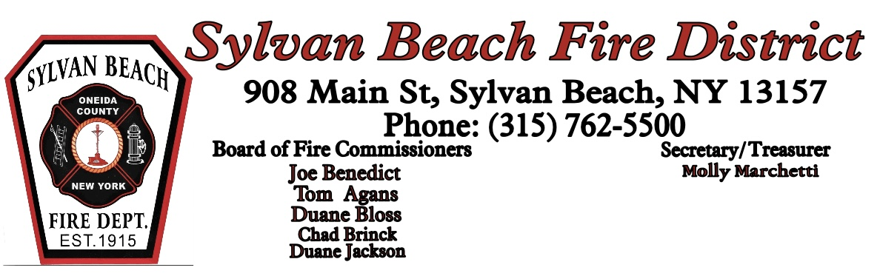

Board of Commissioners(FBOC) Emergency Meeting

February 26, 2025

**Call to Order:** The meeting was called to order by the chairman at 1859 hrs..

**Roll Call:**

Chairman Joe Benedict Present Excused

Commissioner Tom Agans Present Excused

Commissioner Duane Bloss Present Excused

Commissioner Chad Brinck Present Excused

Commissioner Duane Jackson Present Excused

On the evening of February 25, 2025, the west wall of the station leaked due to snow/ice buildup. The purpose of this emergency meeting was to determine a course of action.

Following discussion, motion by Duane Bloss, seconded by Duane Jackson to request a determination from Delta Engineering if the building was structurally sound and safe to occupy. A follow up meeting will be called as soon as possible. All in favor, motion carried.

Meeting adjourned at 1945 hrs.

Joe Benedict

Chairman, FBOC